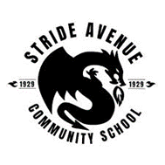
Stride Community School Newsletter

MAY 2026
PRINCIPAL – Mr. Hiltz
HEAD TEACHER – Mr. Cockram
COMMUNITY SCHOOL
COORDINATOR – Ms. Krishna
SECRETARY – Ms. Giovanetti

UPCOMING EVENTS
MAY 6
Primary Spring Concert (630pm)
MAY 13
Welcome to Kindergarten
MAY 15
Sports Day (parents welcome)
MAY 15
Early Dismissal – 1pm
MAY 18
Victoria Day Holiday (no school)
MAY 20
SACC General Meeting – 630pm online
MAY 28
Volunteer Appreciation Tea
JUNE 3
SACC parent meeting and social 630pm (in-person)
JUNE 8
Pro-D Day – no school for students
TO REPORT AN ABSENCE FOR YOUR CHILD
PHONE
604-296-9032, press 2 and leave a message on the absentee voicemail
EMAIL
StrideAvenue.info@burnabyschools.ca

Dear Parents and Caregivers,
Thank you for your continued support and involvement in our school community. We have had several important events recently and are looking forward to initiatives taking place over the coming weeks.
Parent Teacher Interviews and Student-Led Conferences were well attended and provided a valuable opportunity to celebrate student learning and strengthen the partnership between home and school. Thanks to everyone for your participation in this valuable opportunity showcasing your child’s learning.
Our most recent Council Meeting included an engaging literacy update from Megan Aprim, highlighting current initiatives and next steps in supporting student reading and writing at home Parent night literacy-BBy.pptx We appreciate the thoughtful discussions and the ongoing support of our council members. As we engaged in our Professional Development Day a week or so ago, staff were focused on collaborative learning to further enhance teaching and learning for all students.

This past week, we were thrilled to host the Stride Reunion and Farewell event. With over 400 former students, staff, and friends of Stride in attendance, it was a joyful and meaningful celebration of the impact Stride has had on so many lives. Thank you to everyone who helped make this memorable gathering such a success. It was a wonderful opportunity to reconnect and reminisce. A few photos have been posted on the Stride Twitter account @stridesd41
Finally, preparations for our Spring Concert and Sports Day are well underway. Students and staff are working hard, and we are excited to share these celebrations of creativity, teamwork, and school spirit with our families soon.
Thank you, as always, for being an essential part of our school community.
Mr. W Hiltz
Principal

7014 Stride Avenue, Burnaby, B.C. V3N 1T4
604-296-9032 StrideAvenue.info@burnabyschools.ca
STRIDE REUNION EVENT – APRIL 30TH
On Thursday, April 30th, we were proud to host a special reunion at Stride for former staff and students. With our move to the new school coming in September, the event offered alumni a meaningful opportunity to walk the halls once more and reminisce. Guests explored classrooms and enjoyed photo displays organized by decade, with many excited to find and take-home photos of themselves as keepsakes.

Visitors were invited to write a few words capturing their connections to different places in the school. Here are some of their reflections:
- Welcome to the Library
“This room used to be Grade 1 in 1978.” — KM
- Welcome to Student Services (formerly the Main Office)
“I got 10 on each hand here.” — BB
- Welcome to Strong Start
“This room used to be Grade 1 with Ms. Switzer.” — DH
- Welcome to the Gallery
“This room used to be the cafeteria/lunchroom.” — JO & JM
- Welcome to the Music Room
“This room used to be Grade 3 in 1954.” — JA

The evening ended with speeches and a reception in the gym. Indigenous Elder Kanatiio began by expressing greetings and words of thanks to the natural world. We also heard from Kristin Snider-Chair of the Burnaby Board of Education, former Principal John Hodgins (1967-1976), Alumni Nikhil Jain, longest serving current Teacher Vasso Feretos and Educational Assistant Diane Chubb. Ms. Chubb also shared the history of the school song – Stride Pride. Thank you to Mr. Hiltz for sharing a few words from Community Council, Chair – Sara Niekamp and for hosting the evening!


Thank you to the Stride Reunion Committee for organizing such a special evening. We would also like to extend our sincere thanks to Greg Greiner and Sharon Freeman for generously donating baked goods, as well as to the following organizations:


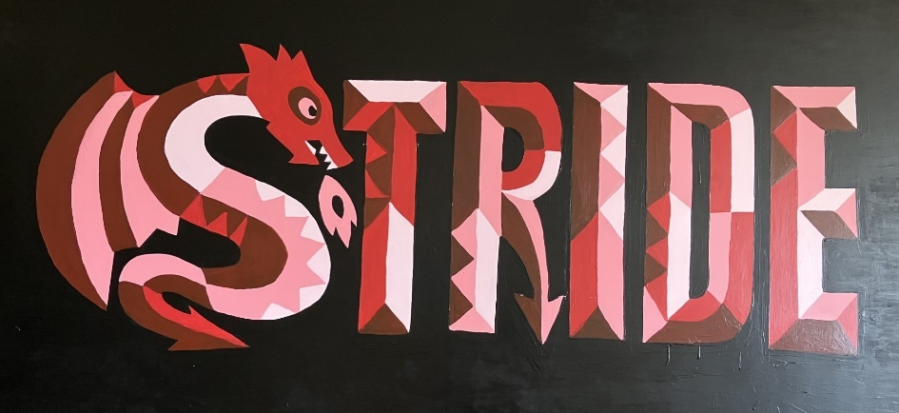
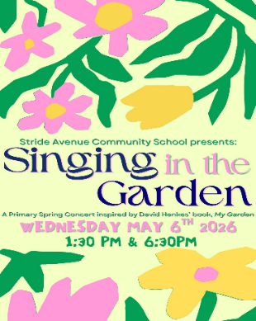
PRIMARY SPRING CONCERT – MAY 6TH
Primary Students have been working very hard learning their songs and dances for the Spring concert. We are looking forward to welcoming families to the concert on May 6th at 1:30pm or 6:30pm. Tickets are required for entrance to the evening concert.


STRIDE SPIRIT WEAR – ON SALE NOW
We’re excited to share that our school is selling Stride Spirit Wear! T-shirts, hoodies, and zip-up hoodies are available in a variety of colors. You can choose from both the Dragon logo and the Stride Pride logo, so there’s something for everyone.


The sale will close on May 11, 2026. Late orders cannot be accepted after this date. All orders will be delivered to the school approximately 4–6 weeks after the sale ends, in time for distribution before the end of the school year.
When placing your order, please be sure to include your child’s name (not the parent’s name) so we can deliver items to the correct student. Please be careful when selecting sizes as items that are delivered can't be returned.
Orders and payments are completed online using the link below:
ORDER HERE Thank you for supporting our school spirit!

MOVING SCHOOLS FOR 2026–2027?

If you know that your child will be moving out of the Stride catchment area and will not be attending Stride Avenue Community School for the 2026–2027 school year, please let us know as soon as possible. Kindly contact the school office at StrideAvenue.Info@burnabyschools.ca with this information. Early notification helps us with planning and organizing classes for next year. Thank you for your support!

INDIGENOUS DANCE WORKSHOPS
In early June Stride students will have the opportunity to learn hoop and powwow dancing. Thank you to SACC gaming grant for supporting the cost of 1 day of these lessons. We are hoping to have a second day of instruction, if we can secure additional funding for it.


STUDENT LEARNING SURVEY – EXTENDED TO MAY 15TH
The BC Student Learning Survey deadline has been extended to May 15th. This annual survey is administered to students in Grades 4 and 7, their parents/guardians/caregivers, and all school staff. The purpose of this survey is to help improve education for all students in British Columbia. Click on the link HERE to complete the survey.

We encourage all parents/guardians/caregivers of students in grades 4 and 7 to participate, as the results are important for identifying and celebrating current strengths, as well as determining areas where the school can focus on improvement.

SPORTS DAY and EARLY DISMISSAL AT 1PM – FRIDAY, MAY 15TH

Families are welcome to attend this exciting day at Stride! Students will enjoy a variety of races and activities; all centered around this year’s construction theme. For Sports Day each student is assigned to a house team with a color—be sure to wear your child’s team color and cheer them on!

At lunch, students on the Hot Lunch Program will receive pizza. For those not on the program, the SACC is organizing a hot lunch delivered to classrooms. Please pre-order by May 11th through School Cash Online. Pizza and samosa combos are available. When ordering please place separate orders for each child, as lunches will be delivered to classrooms. A concession will also be available in the Gallery for additional treats. Students will be dismissed at 1:00pm on Sports Day

STAY SAFE COURSE – APRIL 27TH
On Monday, April 27th, while it was a Professional Development Day for staff and a day off for most students, nearly 30 Stride students participated in a full-day Canadian Red Cross Stay Safe course.
Open to students in Grade 3 - 5, the course focused on staying safe at home and in the community, along with basic first aid skills. The instructor, Andrea, was very impressed with the students’ maturity and commitment. All participants earned their Stay Safe certificate—congratulations to everyone!


CALM AND CONFIDENT PARENTING WORKSHOP
Burnaby Family Life is offering a free program for parents/caregivers in the Community Room every Tuesday from 1230-230pm. Free child-care is provided for 0-5years in the Strong Start room. To register, please contact Sandy at 604-838-6280 or email at sandhya.krishna@burnabyschools.ca

SACC – SPECIAL GENERAL MEETING: WEDNESDAY, JUNE 3RD

Families are invited to the Community Room on Wednesday, June 3 at 6:00 PM to enjoy a light dinner and attend a Special General Meeting. At this meeting, an election will be held for the Community Council in preparation for the 2026–2027 school year. Childcare will be provided for children under 10 years of age.

The Special General Meeting and elections will be offered in a hybrid format, allowing parents and caregivers to join online if they are unable to attend in person.

In the past, elections for SACC Executive members were held in the fall; however, they will now take place annually at the June meeting. This change allows the new council to begin their roles at the start of the school year in September. The SACC bylaws will be updated to reflect this change.
For more information, please contact Sandy at 604-838-6280.

STRIDE AVENUE COMMUNITY COUNCIL - FUNDRAISERS
Money from these fundraisers supports the future playground at Stride and various programs and events for our students. Thank you for your support.

- Big Brothers Clothing Drive
Thank-you to everyone who donated clothes during our recent clothing drive. Our school collected 75 bags of clothes and 15 boxes of household goods. Through your donations we raised _________ for the school.
- Bruno Mars raffle tickets (on sale until June 22).
Purchase raffle tickets online for a chance to win a pair of tickets to the Bruno Mars concert in October. Tickets are 1 for $10 or 3 for $25. Draw date is June 22. Purchase Tickets HERE.
- Freeze Sales Wednesdays (May and June)
Picnic Tables from 2:45PM–3:30 PM
- Popcorn and Slushie Sales Fridays (May and June)
Gallery from 2:45PM-3:30PM

Note: No popcorn or slushies on Friday, May 15th due to Sports Day. (Freezes will be sold at concession).


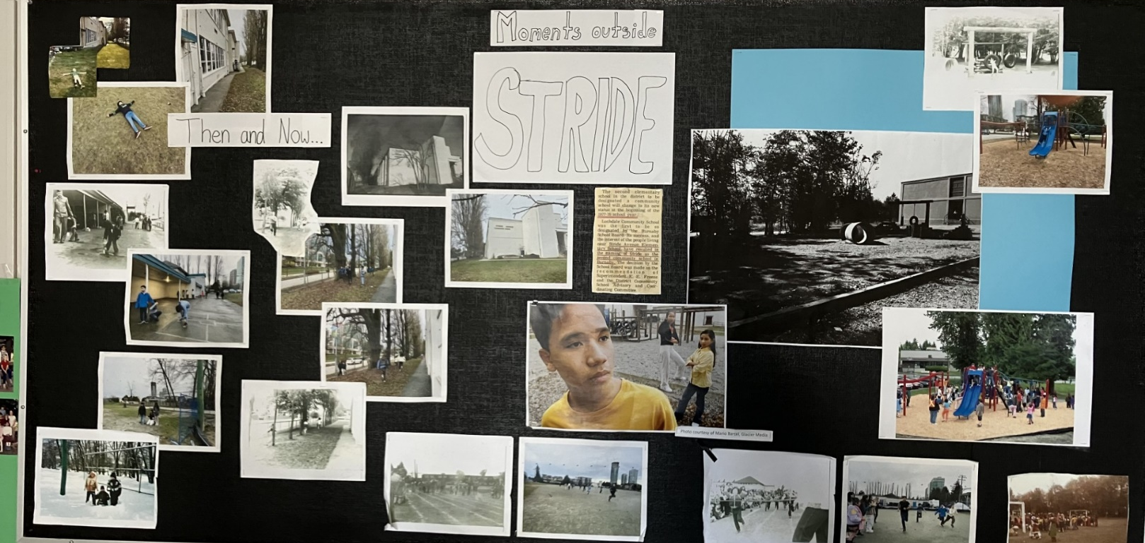
PHOTOS FROM THE STRIDE REUNION

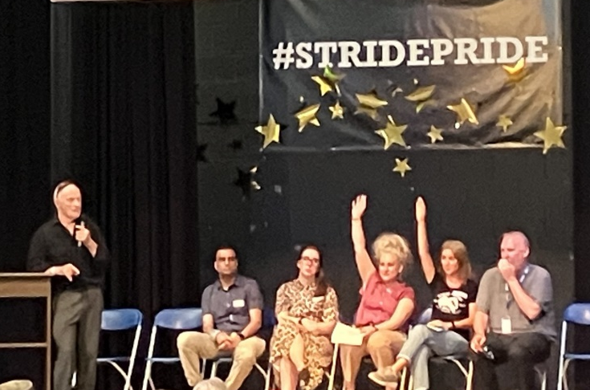

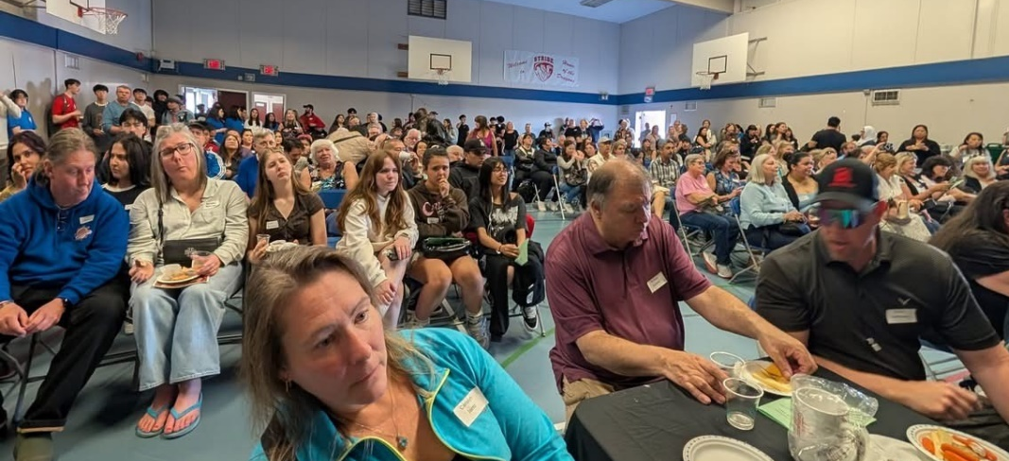
Photo display in the gallery – students recreating photos from the past
Reception and speeches in the gym
Ms. Soon (former teacher) and Mr. Hodgins (former principal)






